**Project Design Phase-II**

**Data Flow Diagram & User Stories**

|  |  |
| --- | --- |
| Date | 10-06-2025 |
| Team ID | LTVIP2025TMID28797 |
| Project Name | Cafeteria Menu Project |
| Maximum Marks | 4 Marks |

**Data Flow Diagrams:**

A Data Flow Diagram (DFD) is a traditional visual representation of the information flows within a system. A neat and clear DFD can depict the right amount of the system requirement graphically. It shows how data enters and leaves the system, what changes the information, and where data is stored.



**Example:** [**(Simplified)**](https://developer.ibm.com/patterns/visualize-unstructured-text/)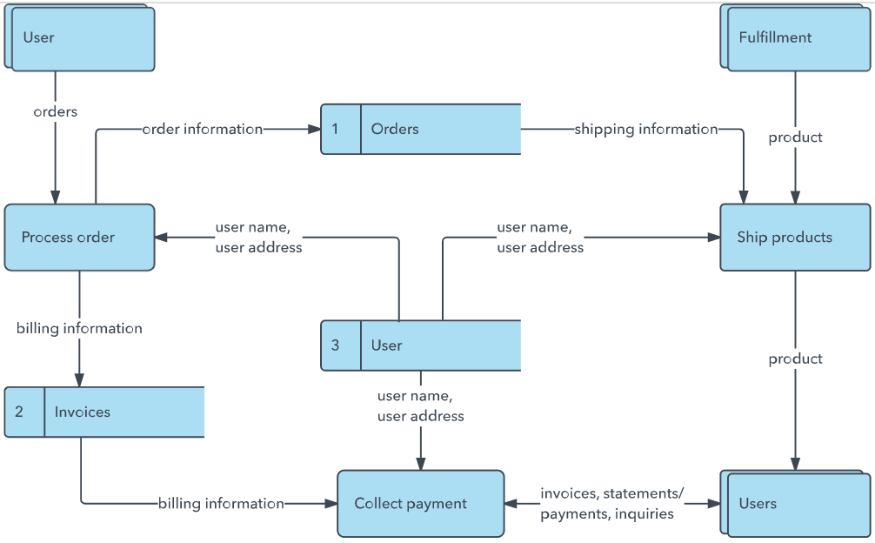

**Data Flow Diagrams** 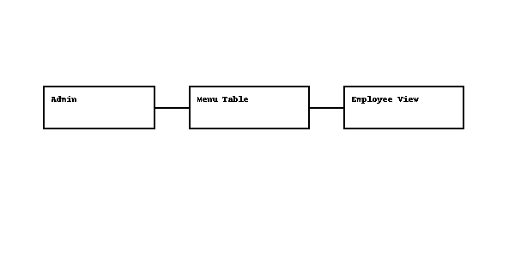

## User Stories - Cafeteria Menu Display Portal

|  |  |  |  |  |  |  |
| --- | --- | --- | --- | --- | --- | --- |
| User Type | Functional Requirement (Epic) | User Story Number | User Story / Task | Acceptance Criteria | Priority | Release |
| Cafeteria Admin | Menu Submission | USN-1 | As an admin, I want to submit a new cafeteria menu using a form | Menu is successfully stored in the system | High | Sprint-1 |
| Cafeteria Admin | Menu Publishing | USN-2 | As an admin, I want to publish a submitted menu using a UI button | Menu status changes to 'Published' and confirmation message is shown | High | Sprint-1 |
| Cafeteria Admin | Menu Review | USN-3 | As an admin, I want to review and edit past menus | Menu table allows viewing/editing (if not locked) | Medium | Sprint-2 |
| Employee (User) | Menu Viewing | USN-4 | As an employee, I want to view the weekly cafeteria menu on the portal | Employees can see published menus with date/menu items | High | Sprint-1 |
| Employee (User) | Historical Menus | USN-5 | As an employee, I want to view past menus for reference | Past menus remain visible but are read-only | Low | Sprint-2 |
| Supervisor | Menu Reports | USN-6 | As a supervisor, I want to view reports on menu publishing frequency and dates | Dashboard/report displays group-by menu date/menu items/menu status | Medium | Sprint-2 |
| System | Data Handling | USN-7 | As a system, I want to store, validate, and update menu data consistently | System prevents duplicate dates and ensures required fields | High | Sprint-1 |